Module 1: Analysis of a Betting Strategy in Sports

Hang Wu

ALY6050

Jan 14th,2022

## Introduction

A report has been made to simulate and subsequently solve the problems where Red Sox and Yankee plays a series of game. Best of 3, 5 and 7 are considered alternated between 2 cities: Boston and New York. The challenges of this project would be to solve the problem which can’t be summarized to a single simulation model (though the result indicates a combination of normal distributions) then simulate using random number sampling (n=10000). We will use R for this project instead of Excel due to its comprehensive abilities and its scriptive nature (which is easy to organize and read).

Since most of the summarization of formula are done by hand (see Appendix) and they are not as organized because there are many changes throughout the building of the report (it’s rather a constant summarization and optimization rather than planning from the start. It's not expected to be perfectly accurate.

## Initial Analysis

The probability where Red Sox (Prb) wins in their home stadium (Boston) is 0.59, the probability where Yankee wins in their home stadium (New York) Pny is 0.56, we can infer that RedSox losing in Boston is 0.41 and winning in New York is 0.44.

There are also multiple scenarios to consider because the series’ length depends on the current state of the winning. For instance, if Red Sox wins 3 straight games, then it will end the series early, otherwise they would need to play the 4th game. This is important because it would lead to different results if this assumption were made.

To simplify Part 1 and 2 (it’s not really simplified in the R script, but Part 3 has used the simplification), we let the probability that Red Sox wins in the first city be “a”, and the probability that Red Sox wins in the second city be “b”. We just need to change the value of a and b in part 2 instead of recomputing the entire thing, which would save precious time. For Part 3, similar strategy is used, Px1, Px2 and Px3 are constructed using a summarization of the formula done by hand, after that a=(1-a), b=(1-b) are used to calculate the probability of the first 3 scenarios with winning changed to losing. For Part 4, the last 4 probabilities are also computed this way.

Please note that this computation strategy is done after 80% of the work is done, and it changes the results significantly, therefore I don’t expect any of the results to be perfectly accurate. In fact, the reason why summarizations are needed is because the scenarios require the game to stop after the majority win or lose are reached. (I.e. 3 wins out of 5, 3 losses out of 5, 4 wins out of 7, 4 losses out of 7) , therefore some of the report and the R script need to be rewritten several times in order to reflect the changes. And since we aren’t allowed to communicate answers (which would result in cheating) which is the opposite of how real-world works, therefore rough notes are attached to the Appendix to record the thought process and the evolution.

(See Appendix for the rough notes).

## Analysis

### Part 1 and 2

Part 1 and 2 deal with the same number of matches with the only difference being the starting cities. New York for Part 1 and Boston for Part 2. therefore we can denote “a” = 1-Pny and “b” = Prb for Part 1, and the reverse for part 2.We will then conduct different scenarios, in order for Red Sox to win the series, it has 3 scenarios: winning the first 2 games, winning the last 2 games, or losing the second game and winning 1 and 3. It would become a*b,(1-a)*b*a and a^2*(1-b). There isn’t much to simplify so we will simply get the result: 0.484352 and 0.560972 respectively.

Notice the higher chances of winning if the starting city is the home city. As this becomes important when we do deeper analysis on Part 3.

The net win is calculated as follows:

#X1 = -2100 when R loses both game 1 and game 2, lose 2

#X2 = -1100 when R wins only game 1 or game 2, meaning that win 1 once and lose 2

#X3 = 950 when R win game 1&3 or game 2&3, win 2 and lose 1

#X4 = 2000 when R win 1&2, win 2

With the estimated expected net win for P1 to be 53.2892 and P2 to be 124.9034. 134% of increase in net earnings when the games switch starting city to home city. The estimated standard deviation for P1 and P2 respectively are 1486.07 and 1384.851, indicating less data variance.

Simulated results using random number generator, mainly the function sample with replacement is used to simulate 10000 records of the 4 scenarios above for P1 and P2. A more lucrative winning potential is indicated in the second graph, indicating that the betting strategy should focus on the starting city.

With the simulated mean to be 64.47 and 144.42 and different upper and lower bound, the estimated results falls into the CI with 95% confidence. P2 indicates a much better betting condition for Best of 3 games.

Chi-Square Goodness of Fit Test rejects null hypothesis (value = 14.44,16.13 respectively for P1 and P2, which are all greater than the critical value 7.81) and proves that it’s statistically significant enough to show the differences for each type of net winnings regardless of the starting city of the series.

By observation we see that there are more chances to win 1&3 or 2&3, and to win both 1&2(especially when start in Newyork), this means that it would minimize loss while betting only when you win the first game. Winning 1&3 also has better probability than winning 2&3 (0.19 and 0.11 respectively), therefore it’s wise to bet only when the first game win.

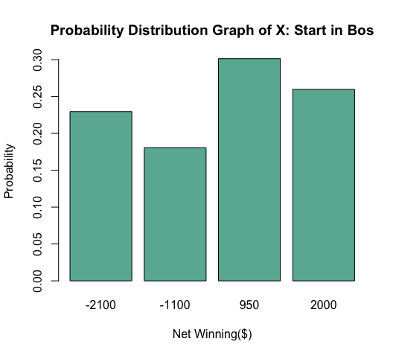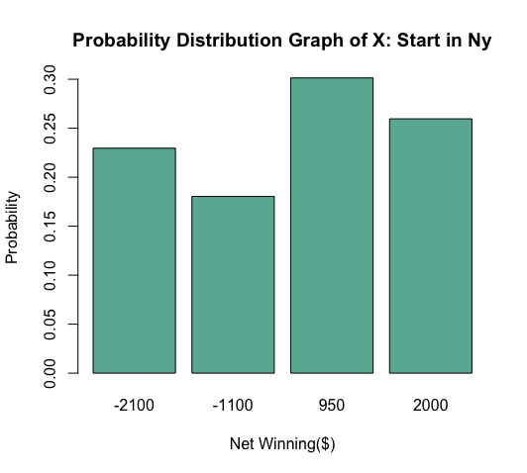

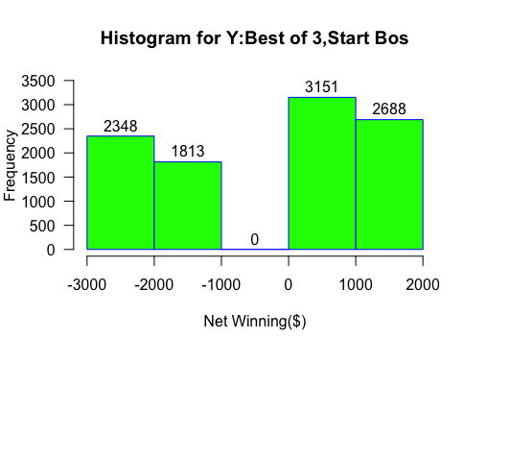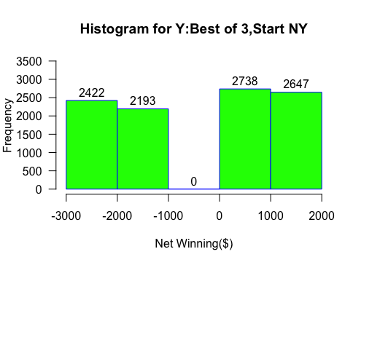

### Part 3

Using the strategy indicated above, we summarize 6 equations for the best of 5 games. Originally 5 choose 3 = 10 possible combinations of results can occur. Let “a” = the probability Red Sox wins in the first city, “b” be the probability of winning in the other city. We can change the probability of seeing the results.

The 6 equations are used to calculate the probability of red Sox winning, which is 0.500 starting in Boston, and 0.56 starting in New York (although only New York is required as the starting city, this is to show the difference). A net loss is expected to be -45.79888 with the standard deviation to be 1731.125, higher than the best of 3 games. Out of 6 combinations of losing 2 games out of 5 while winning the other 3. 50% of them has the first game won and 50% of them has the second game won. Therefore, it’s wise to stop at the fourth game regardless. Out of all winning combinations, 7/10 of them has the first game won. Therefore, it’s not wise to continue if the first game is lost. if the first two are loss, only one of the 10 possible winning combination can generate a win (win the next 3 games) Even if the second game is in Boston, which is a 56% of winning, it’s still not worth the potential risk of losing –1150.

Chi-Square Goodness of Fit Test. Doesn't reject the null hypothesis after several runs (more than 5, value less than 7, which is not greater than the critical value 7.81), therefore it’s **not** statistically significant to distinguish different category of net winning between probability distribution of x and the frequency distribution of y.

X1 = 3000

X2= 1950

X3 = 900

X4 - -3150

X5 = -2150

X6 = -1150

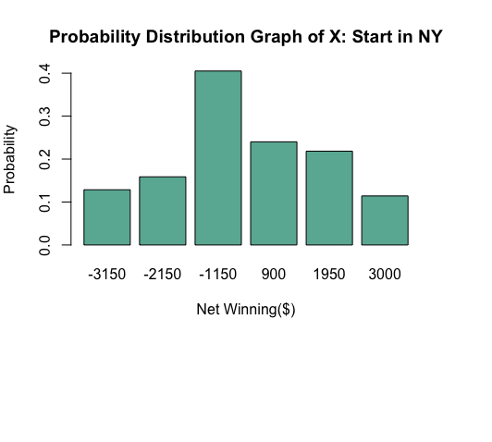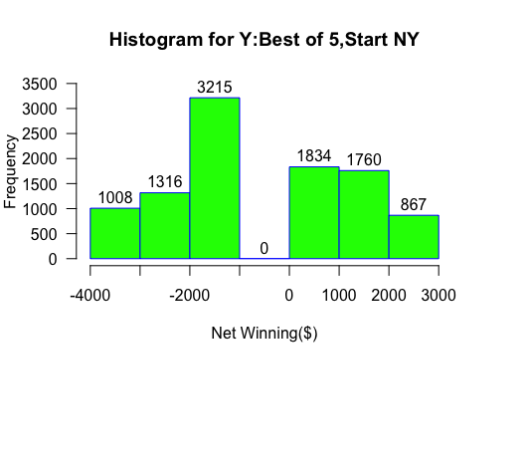

### Part 4

Best of 7 games would generate a 7 choose 5 = 35 combinations (the actual combinations gotten is 30, I might do it wrong), the possible combinations would consist of either 4, 5, 6 or 7 variables, see appendix for the rough notes.

8 scenarios are presented for net winning. The frequency plot is plotted to demonstrate the occurring frequency of each net winning.

X1 = 4000

X2 = 850

X3 = 1900

X4 = 1950

X5 = -3200

X6 = -2200

X7 = -1200

X8 = -4200

Simulated results show that there are more chances to win, 160.1119 is the expected winning with the standard deviation of 2647.91, which is greater than all of the previous games. Chisquare of 6.17 is gotten from the simulated result, and it can’t reject the null hypothesis (6.17<7.81) and it’s not statistically significant (alpha = 0.05) enough to distinguish between categories. The simulated mean is 168.57 and it’s really close to the expected value of 160.11. The expected value lies in between the CI with the boundary of (40.99 and 222.54). Overall, the simulated results do represent the probability distribution, but it’s not significant enough.

Since the highest probability of all winning combinations is to win 4 out of 5 games (winning 4 games before the 6th game begins, thus you won’t need to bet on the 6th and 7th game,22.48%), it’s wise to study the pattern of this scenario. Out of only 5 possible combinations of winning 4 out of the 5 games (or losing 1 out of 5 games), 4 of them have won the first game won, 3 of them have the second game won. Therefore, it’s wise to finish the first 2 games, since only 1/5 of the winning combo depicts the second game loss, it’s wise not to continue if the second game loses, and if the second game wins, there are approx. 50% of chances that you need to play the 6th game (there are 6 out of 13 combinations that has the first 2 games win, and because it multiplies with another p, and p is close to 50% regardless of winning or losing, there will be half of the chances that the game will enter to the 6th game), this means that there’s a probabilities of winning 1050 less, although the probability is slim, it’s wise to stop once 2 game losses are encountered, the probability of winning 4 games after losing 3(7.41%) is only slightly greater than winning 4 games straight (6.09%), and similar to losing the next 4 games (7.2%). Since losing 3 games after winning 3 games would result in a net loss, therefore stopping at the 2nd loss is the wisest thing to do.

As stated, the probability distribution contains a different shape than the histogram of Y, where the latter shows a Normal Distribution and the former doesn’t show a particular shape.

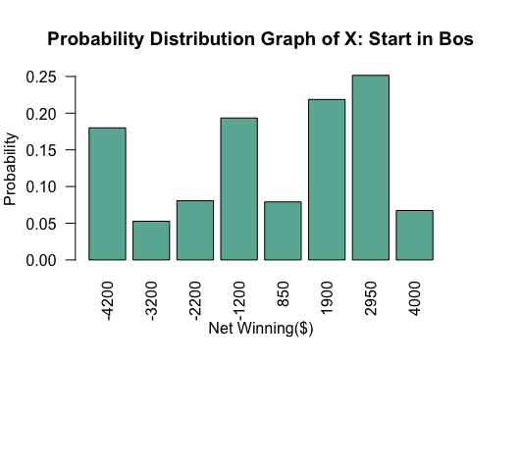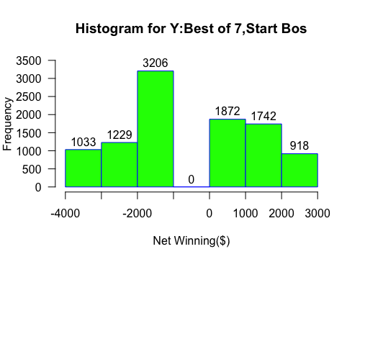

### Conclusion

This report concerns with the analysis and the betting strategies of 4 games, where the first two are the best of 3, with different starting cities, and the last 2 are best of 5 and 7 respectively. The longer the series the more standard deviation the data would have, also the longer the series there presents more probability of losing, although starting in Boston would definitely help as the expected income would still be positive for the best of 7, but the best of 5 saw a expected loss overall. The best strategy seems to be only betting after winning the first and preferably the second game, but even that could result a potential $50 loss. So maybe the best strategy is just don’t bet on any game.

**Reference**

*Bluman, A. G. (2009). Elementary statistics: A step by step approach*. New York: McGraw- Hill Higher Education.

*John Blischak, Daniel Chen, Harriet Dashnow, and Denis Haine (eds): "Software*  *Carpentry: Programming with R*." Version 2016.06, June 2016, <https://github.com/swcarpentry/r-> novice-inflammation, 10.5281/zenodo.57541.

*Kabacoff, R. (2015). R in action: Data analysis and graphics with R*. <http://www.cs.uni.edu/~jacobson/4772/week11/R_in_Action.pdf>

*Venables, W.N., Smith, D.M, R Core Team (2020) An Introduction to R*: A Programming Environment for Data Analysis and Graphics Version 4.0.3 <https://cran.rproject.org/doc/manuals/r-release/R-intro.pdf>

*R errors explained: Incomplete final line found by readtableheader*. ProgrammingR. (n.d.). Retrieved October 2, 2021, from [https://www.programmingr.com/r-errormessages/incomplete-finalline-found-by-readtableheader/.](https://www.programmingr.com/r-error-messages/incomplete-final-line-found-by-readtableheader/)

Droglenc. (2021, January 25). *Bulltroutrml2: Ages and lengths of Bull Trout from two Rocky Mountain Lakes... in droglenc/FSAdata: Data to support Fish Stock Assessment ('FSA') package*. BullTroutRML2: Ages and lengths of Bull Trout from two Rocky Mountain lakes... in droglenc/FSAdata: Data to Support Fish Stock Assessment ('FSA') Package. Retrieved October 6, 2021, from <https://rdrr.io/github/droglenc/FSAdata/man/BullTroutRML2.html>.

Dugar, D. (2020, July 18). *Skew and kurtosis: 2 important statistics terms you need to know in Data Science*. Medium. Retrieved October 6, 2021, from <https://codeburst.io/2-important-statistics-terms-you-need-to-know-in-data-science-skewness-and-kurtosis-388fef94eeaa>.

Appendix

Rough Notes for computing Best of 5

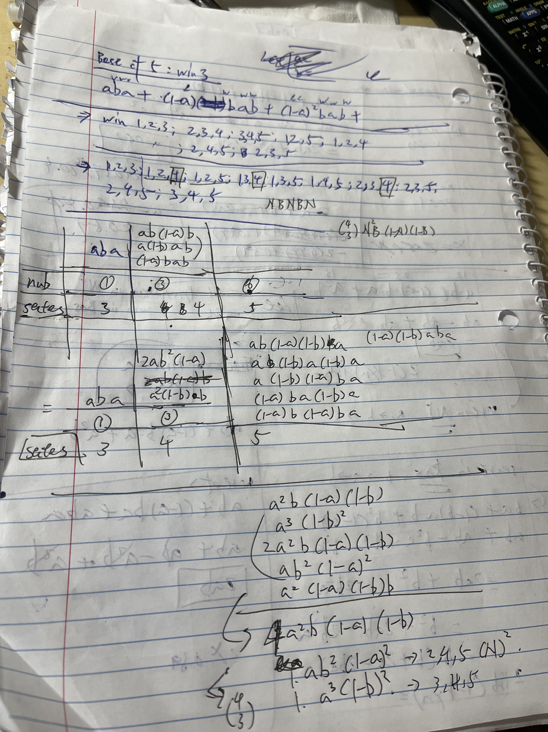

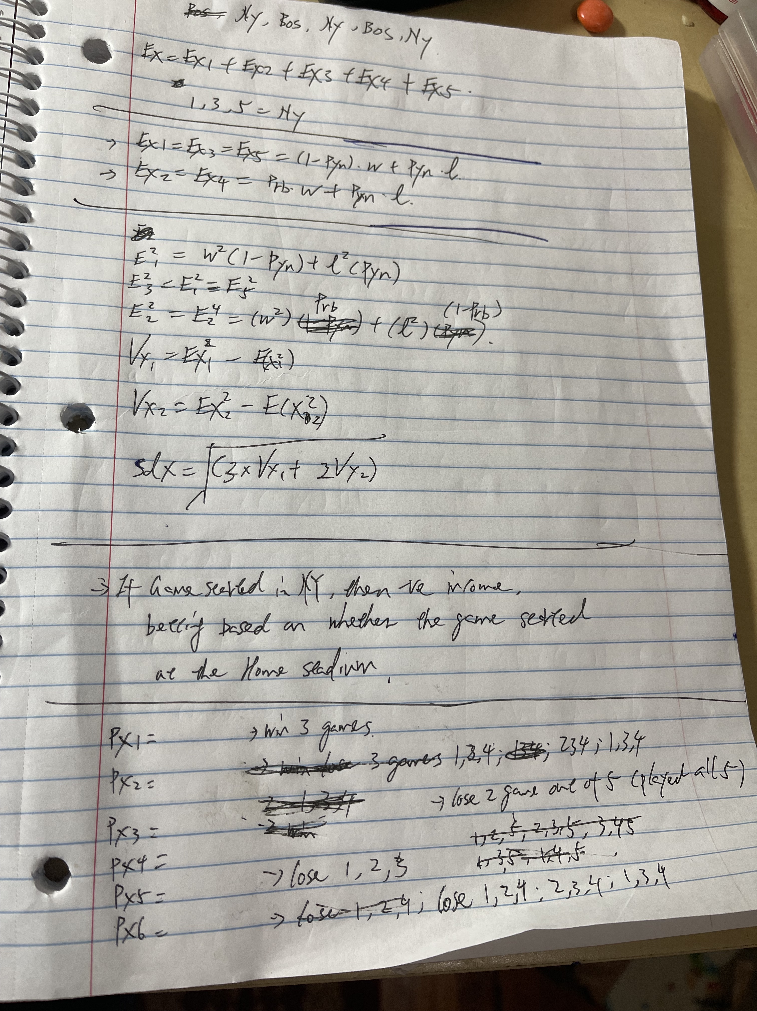

Rough Notes for computing best of 7

